Name: Kirils Krivojs…………………………………………………..
With the aid of suitable diagram, explain Von Neumann Architecture
The architecture consists of Input/Output equipment, Main memory and
Central Processing Unit that has Arithmetic Logic Unit (CA) and Program control unit (CC).
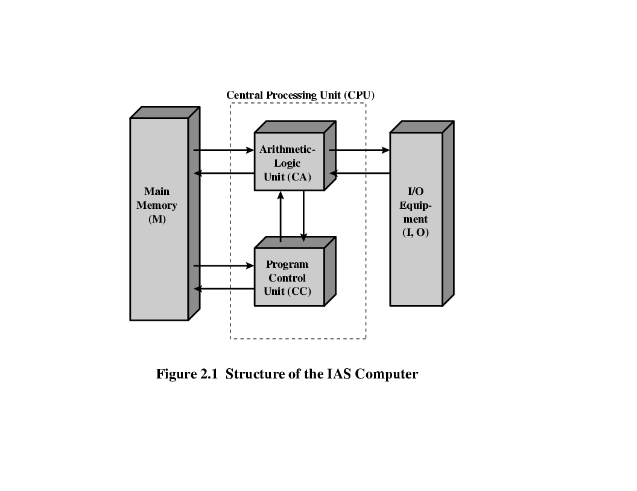
With the aid of suitable diagram, explain Bus Architecture
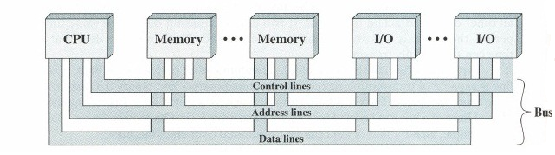
Bus Architecture consists of the same elements, but has multiple communication pathways the lines can be classified into three functional groups:data,address, and control lines
Explain the difference between Von Neumann and Bus Architectures
They have the same components, but the way the are connected is different.
The advantage of Bus Architecture is in its interconnection. It allows to change any component on the bus because they are equally structurised
………………………………………………………………………………………………………………………
Which architecture is used in Mac Pro computer with Xeon processor and why?
It has hybrid architecture. CPU and I/O is similar to von-neuman architecture but the storage has buses at in the Bus Architecture……………………………………………………………………………………………………………
Explain difference between 32-bit and 64-bit architecture
…………………………………………………………………………………………………………………………
…………………………………………………………………………………………………………………………
Explain difference between address and data buses
They have different purposes ……………………………………………………………
…………………………………………………………………………………………………………………………
Explain relation address bus size – memory size
If we want more memory, address bus must be wider………………………………………
…………………………………………………………………………………………………………………………
Explain data bus and computational performance
Data bus wider, performance is higher………
…………………………………………………………………………………………………………………………

